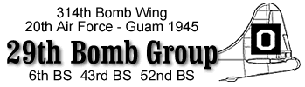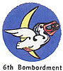

29TH BOMB GROUP ASSOCIATION NEWSLETTER
2605 Paddock Lane
Lancaster, PA 17603

Phone 717-393-3139
E-mail apawliko@comcast.net

JUNE 2009

29th Bomb Group Farewell Reunion Washington D.C September 4-7, 2008

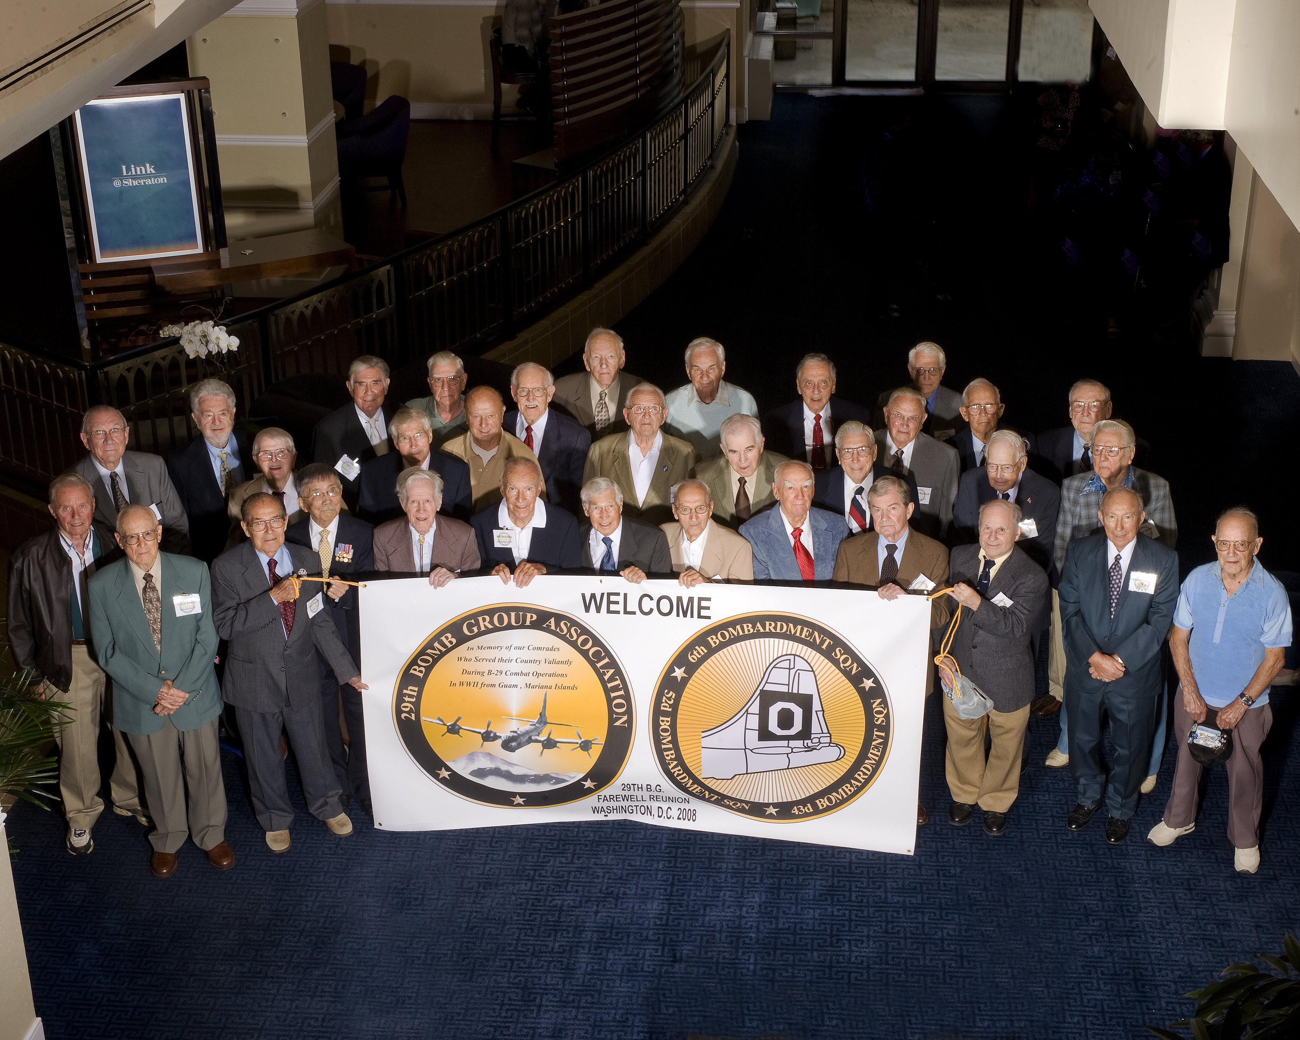

Members of the 29th Bomb Group Association attending the Washington D.C Reunion.
Photo thanks to Warren Johnson, Jr.

Thanks to everyone for making the September 2008 Farewell Reunion a success! We had 40 29th BG veterans in attendance and well over 200 people attend overall. Everyone’s participation and enthusiasm really made the reunion a rewarding experience for not only the attendees and the organizers, but also for the staff of the Sheraton National Hotel, the Arlington Limousine Service bus drivers, and the staff at the Udvar-Hazy museum. The group really made a lasting impression. Speaking for the organizers, the music act Tre Voche, and our guest speaker Brigadier General Harencak it was our honor to be able to recognize the veterans of the 29th Bomb Group Association, along with their families and friends.

Special thanks to Warren Johnson for taking the time to interview our veterans and take photographs. Warren has provided a CD with photos that were taken at the reunion, including the group veteran photo, and the group attendee photo (both of which turned out great!). If you have email capability, and would like copy of these two photos, please email Anthony.Ferraro@Navy.Mil. If you don’t have access to email, and would like a hard copy of the photos mailed to you please write to Anthony Ferraro, 22096 Willis Dr. California, MD 20619 and we will send them to you. For a CD of all of the photos, we can make a copy of the CD and mail that to you as well if you request it.

As you all know, the 29th Bomb Group Association is in the process of dissolving, and it is now up to the younger generation to develop a new entity. With respect to a follow-on organization, we had discussions at the reunion and have selected the name “The 29th Bomb Group Heritage Society”. This organization’s general purpose is to be a witness for the 29th Bomb Group, lest we forget. The exact details for the organization have yet to be formally decided, and we are looking for participation and ideas. For our veterans, we would like to formally invite all of you to be advisors. If the organization becomes a “legal entity” then we will have to do what it takes to set that up properly. If we base the organization “on-line”, and don’t handle any funds, then it may make it a little easier to set up. One thought is to expand the current website to include items (photos, stories, etc.) sent in from our members. Suffice it to say the organization exists in our hearts and minds for now, and we would like to collectively work towards a way to thank our veterans and remember the courage they displayed so many years ago so that we could grow up in a land of liberty (which just might mean we will all have to get together again for a fun weekend!)
Anthony Ferraro

A MESSAGE FROM OUR PRESIDENT, BEN ROBERTSON: Joe Chovelak and I have been working for several months on the mechanics of the dissolution of the 29th Bomb Group Association and the distribution of our memorabilia and artifacts. Our objective has been to find a place where it can be preserved in perpetuity and be displayed and promoted for the benefit of all who may be interested.

In this endeavor, one or the other of us has talked to personnel at the Air Force Academy in Colorado Springs, the Smithsonian Institute in Washington, D.C., Wright Patterson at Dayton, Ohio and the Boeing Museum of Flight in Seattle, Washington.

Our conclusion after these inquiries was that none were desirable for us as our history is not of particular interest to them. Our stuff would be filed away and forgotten or buried somewhere and perhaps never see the light of day unless a researcher happened to make a specific inquiry. These institutions are too large to give us the attention we want. Following this contact was made with the Pratt County Historical Society Museum at Pratt, Kansas – our old training base. This is a 501 (3) entity established in 2001 and has associations with The Pratt County Historical Society (also features local history), The Kansas Historical Society, the Bombers on the Prairie Museum, and the All Veterans Memorial Complex. The Pratt County Historical Society was founded in 1968 to preserve and exhibit various County historical records. They have indicated that they would welcome our memorabilia and display it prominently. They have a museum building on the airfield and have been granted title to the old parachute building which will enable them to expand the facility even further.

They will be supported locally by the City Tourism Committee and the Airport Authority as well as a commitment from the Kansas Historical Society to continue the objectives and goals and the operation of the Pratt County Museum if it should fail. Failure, however, is not anticipated as the organization generates a steady flow of income from program and admission fees, space rental and reunion accommodations, sales of books and videos from the gift shop as well as individual gifts, corporate and foundation funding and government grants and contracts.

Therefore, with the sincere reception we have been granted from the officers of the museum, we have selected it as the repository of our memorabilia. Joe Chovelak has already started shipping records to them. We will keep the membership of the 29th Bomb Group Association advised of the process as events occur.

Ben Robertson

A MESSAGE FROM OUR HISTORIAN, JOE CHOVELAK:
Welcome to all. I hope the New Year finds you in good spirits and good health. I wish to thank all of you for all of the prayers since my wife’s surgery. Lorraine is feeling much better and she will be starting her physical therapy very soon. Thanks.

As you all know, I have spent the last 23 years doing research on the Lost Crews. The intent of this project was to compile accurate records and have them available for future generations to consult. What you may not know is that the work has already helped families find their fallen heroes. During these years, I received numerous phone calls from families anxious to look over the records. One notable example was the Miller family who never found any information until the year of 2007. Sue (Miller) Eagle waited 62 years to get information about her Uncle Ralph.

At the Farewell Reunion in Washington, D.C. the Board voted to dissolve the Association and at that time I was charged with finding a new home for the historical documents. It was a great shock when I found that none of the museums would display our documents. Instead they would take the documents and retire them. It was devastating to find out that no one wanted to display our documents. Then I received an email from Milton Martin (Webmaster) from the museum at Pratt, Kansas. He wanted an answer regarding WWII documents. We talked for an hour and I suddenly felt that we might have a new home for the documents. After a few days of going over everything, I approached Milton and asked him the big question, “HOW WOULD YOU DISPLAY OUR DOCUMENTS IF WE GAVE THEM TO YOU?” The answer came back, “ANY WAY THAT YOU WANT IT DONE AND WITH HONOR!” That was the rest of the story.

The next step was to find a building which turned out not to be a problem. The parachute building was available and it was to be changed to a HISTORIC BUILDING. That change has now been done. I must tell you that Curator of the project Phillip Schultz and the Webmaster Milton Martin are the two people responsible for our good fortune. A larger staff is being organized and we welcome all of them.

Therefore my task at hand is to inventory the collection before it can be shipped. Due to the quantity of records, the disposition will be done in several phases and will culminate in orientating their staff to the contents. I would like to thank our daughter Elissa, (a librarian), who came to the rescue and helped to systematize the collection. The orientation is a critical step which will ensure a smooth transition for those seeking information. At this time, I can not be sure when the entire collection will be available but the intent is to have it in Kansas within 6 - 9 months. Phase 1 & 2, out of 8 phases are completed, phase 3 will start the last week of March.

It has been brought to my attention about all of the personal memorabilia items that we have and how they may end up in a wastebasket. Do not let it go in that direction because I have a plan that will take care of that. Please send them to the (MY FAVORITE BEST) program at our new home. More details to follow and contact Joe Chovelak. I have the first gift from Robert and Jean Axthelm who will send in his flight jacket with a photo and a note. It will be displayed after delivery to our new home. Details to follow.

Please share the following contact information with anyone who wants to view the collection. The staff in Kansas is committed to making these documents available to future generations. It is with your help that the memory of the 29th Bomb Group will live on.
Contact Info: UNITED STATES AIR FORCE---HISTORICAL RESEARCH CENTER.
Maxwell Air Force Base, Alabama

Documents are also available at: The Library of Congress, Washington, D.C.
.
Audiovisual Archives Division
National Archives
Washington, D.C.

I have said my fond farewell at our Washington reunion, then said a farewell at the Library of Congress, and now will send a fond farewell from myself and my family who have helped me for all of these years: my wife who allowed all the time it took over the years to create the 29th BG, our daughters Elissa, who helped with the reports and research, Cynthia, who proofread all of the newsletters, and Laura, who helped with the check books and purchases. Peter Woytowitz and I started the 29th BG at the first reunion at the Air Force Museum in Dayton, Ohio in August 1985. We bid FAREWELL TO ALL. See you all in Pratt, KS soon.

Farewell
Joe Chovelak
29th Bomb Group
March 2009

LIBRARY OF CONGRESS
by Joan Blyth and Donna Voorhees
On the clear, warm morning of Monday, September 8, 2009, a small party of 29th Bomb
Group members led by Joseph Chovelak met in the lobby of the Sheraton National Hotel on the first leg of their journey with Joe, to deliver his collection of the 29th Bomb Group's important records documenting their history, their missions, and the list of those brothers lost over the seas of Japan during World War II.

After meeting at Representative Judy Biggert's office, she led us through the labyrinth of
infrastructure to the offices of Bob Patrick, Director of Veterans History Project.
Once in the presentation room, Ms. Biggert introduced Joseph Chovelak to Mr. Patrick so
that he could present Mr. Patrick the 15 items he wished to have put permanently in the
Library of Congress to honor the 29th Bomb Group and the sacrifices they made to our
winning the war. Mr. Patrick commended Joe on his "tireless work to insure that the exploits of the 29th Bomb group are to be preserved forever." These records are to be permanently housed in the Library of Congress from this time on.
During and at the conclusion of this ceremony, pictures were taken of the people attending, Representative Judy Biggert, Bob Patrick, Joseph Chovelak, presenter, Anthony Ferraro, Robert Jones, Faye Jones, Timothy Leary, Donna Voorhees and Joan Blyth.
Following the ceremony a tour of the Library of Congress had been planned for the group.
Below you will find the "Inventory of Gifts" presented to Mr. Patrick and The Library of
Congress by the historian of the 29th Bomb Group, Joseph Chovelak.

INVENTORY OF GIFTS
1. Book Introduction of Historical Research Center
2. Book Roster of men on Guam in 1945
3. Book Missions to Japan, Life on Guam
4. Book Short History of the 29th Bomb Group
5. Book Henry Erwin Memorial Pamphlet
6. Book Memorial of the Halteman Crew
DVD’s Loss including Memorial Plaque
7. CD History of the 29th BG converted from microfilm
8. Book Air Crews of the 29th Bomb Group
9. DVD "Pacific Theater" narrated by Jerry Dunphy on a Return to Japan in 1984
10. DVD Reunion at Nashville, TN with a tribute to Colonel Carl Storrie
11. DVD Reunion at Kansas City, MO with a tribute to the Shumate Crew
by the Ferraro Family
12. DVD "Bomber Boys" by the Nass Family and produced by Sue Nass
13. Book "B-29 The Lost Flight of 428" written by TC Geary
14. Book "The Fallen" by Marc Landas, a true story of American POWs and
Japanese Wartime Atrocities
15. Book "Bringing the Thunder" by Gordon Bennett Robertson, Jr.
The missions of a WWII B-29 pilot in the Pacific
*Periodic updates and revisions will be provided.

A LETTER FROM DON NASS: I stopped at Pratt, Kansas, on my way to Wisconsin from Arizona, arriving there late in the afternoon of Wed. May 6th. That evening I attended a meeting of 10 very enthusiastic members of a committee formed to restore the former parachute building into what will be called "Bombers on the Prairie Museum". This project will begin in November of this year and will be located about 100 yards from the completed memorial of the 4 groups that trained there during the war. The memorial itself is outstanding, consisting of a concrete platform about 50 by 100 feet with imbedded and raised bronze plaques listing names, groups and fatalites at the airfield during training. Our memorabilia will be housed and displayed in the museum.
Philip Schultz, Milt Martin and Marsha Brown are the core people working on this project. All three are very competent. Marsha is the curator of the Pratt County Historical Museum in downtown Pratt. Phil and Marsha gave me a tour of this building which was formerly a lumber yard. I have never in all my travels seen such a well arranged, authentic, life-sized display of what life must have been like 100 to 200 years ago in that area. There is no doubt in my mind that our memories and our history will be in competent hands in the same place where we created them so long ago.
In February of 2009 the parachute building was added to the Kansas State Historic Registry and as of April, 2009 it is on the National Registry of Historic Places. The B-29 Museum Group will take possession in November, 2009.
-Don Nass

IN MEMORIAM: Our deepest sympathy to the families of the following members who passed away.

Spino, James 43rd Squadron, Date of death unknown
Vogt, Geneva Wife of Robert Vogt, 2006
Myers, Helen wife of Lew Myers, 9/1/2007
Burke, Edward G. Left Waist gunner, Levinsky’s crew 6th Squadron, 3/16/2008
Sawyer, Allan R. #2 engine man, Karther’s ground crew, 6th Squadron, 10/1/2007
Greenfield, Richard Co-pilot, Coates crew, 6th Squadron, 2/27/2006
LeMon, Robert E. Bombardier, Roach’s crew, 6th Squadron, 1/29/2008
Probandt, Felix B. CFC Gunner, Salm’s crew, 6th Squadron, 3/4/2008
Painter, Robert M. Radio Operator, Moore’s crew, 6th Squadron, 4/10/2008
Ringham, James T. Radar Maintenance, Ground Crew, 43rd Squadron, 5/10/2008
Hawks, Charles B. Aircraft Commander, 43rd Squadron, Early September 2008
Miller, John H. Flight Engineer, Rudiger’s Crew, 52nd Squadron, 5/23/2008
Hines, John P. Bombardier, Bishop’s crew, 6th Squadron, July 2007

As this final newsletter of the 29th Bomb Group Association comes to a close I would like to thank all of those that made this such vibrant group. Thanks to the Officers and Directors: Ben Robertson, Joe Chovelak, Pete Woytwitz, Glenn King, Gene Bowers and Charlie Nuhfer. Thanks to the Assistant Historians for all of their efforts: Anthony Ferraro, Joan Blyth and Bruce Robertson and Fred Bouzek, our webmaster. A remembrance and thanks to our deceased Officers and Directors: Maurice Hooley, Harry Mitchell, Fred Pawlikowski, Jim Livingood and Richard Polleys. A big thanks to all who hosted the reunions. I don’t have a list of names but we all know who they were and we thank them immensely.
Finally thanks to all the members of the 29th Bomb Group Association. You are the reason we gather to remember all that you have done and sacrificed for us and for the USA.

This does not mean that our remembrances come to an end. At the Washington reunion, a core group met and decided that as the 29th Bomb Group Association comes to an end, a new group should be formed to continue to Honor and Remember the part of the Greatest Generation known as the 29th BG. To that purpose we formed the “The 29th Bomb Group Heritage Society”. Anthony Ferraro has agreed to be the acting president, I agreed to be the acting secretary and Tim Geary agreed to be the acting historian. There were others to help form the core group. If you would like to help with this group, please contact Anthony Ferraro. We can use help in many ways. If you would like to fill one of the offices, please let us know.

The next big pressing issue is to find a committee to host our first reunion. It seems to me Pratt, KS would be a great place to hold it. Someone please volunteer to host this event. There are plenty of people with experience to help and assist. Second and third generations, it is time to step up and help honor our fathers and grandfathers.

We look forward to hearing from you and seeing everyone again.

Respectfully Submitted,

Allan Pawlikowski

